# Activity

## Create,Edit Meeting Request

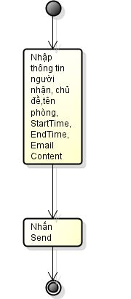

# Sequence Diagram

## Create Meeting Request

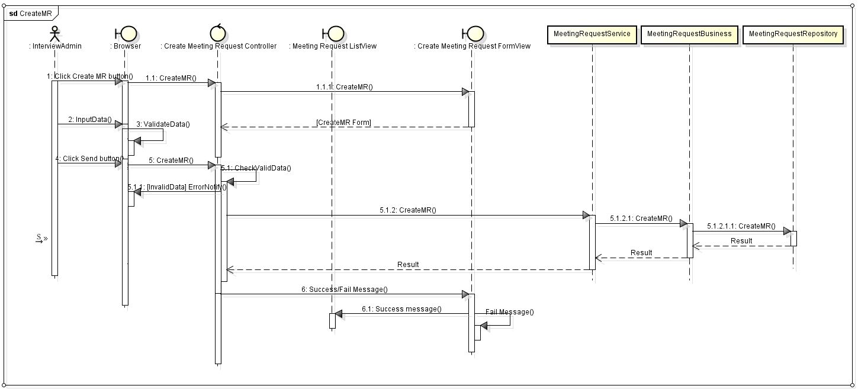

## Edit Meeting Request

